CYPRESS:

Cypress (cy) is a open source front end testing tool ie tests javascript code.

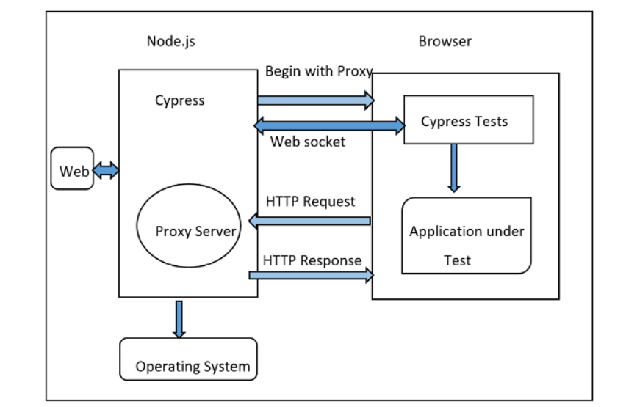

To install cypress we nee to first download node js

Npm init – to create the package.json

Npm install cypress –save-dev

Nodes_modules/.bin/cypress open **OR -> open the test runner which helps to execute the testcase and here in cypress it provides a good user interface to check the execution of the test case.**

Npx cypress open

For any cypress sort of a project the below folder structure will be created by cypress itself:

Fixtures: holds the test data in the form of key value pairs.

Integration: All the test cases should be written here.

Plugins: prior / post events for a testcase are stored here.

Node_modules: heart of the cypress, all dependencies of npm are here.

Cypress.json: holds the default configurations

Package.json: holds the project configurations

Example 1:

This new test called sample.spec.js should be under the integration folder:

// test suite name

describe(simple Test', function () {

// Test case

it('Scenario 1', function (){

// test step for URL launching

cy.visit("https://www.google.com/");

});

});

To execute this:

cypress run --spec "<spec file path>"

Example 2:

describe('mysuite', function()

{

it('verify the title pos', function()

{

cy.visit('https://demo.nopcommerce.com/')

cy.title.should('eq', 'nopCommerce demo store')

})

it('verify the title neg', function()

{

cy.visit('https://demo.nopcommerce.com/')

cy.title.should('eq', 'nopCommerce store')

})

})

Example 3:

describe('Locators example', function()

{

it('types of locators', function()

{

cy.visit("https://demo.nopcommerce.com/")

cy.get("#small-searchterms").type("Apple MacBook Pro 13-inch")

cy.get("[type='submit']").click()

cy.get("#addtocart_4_EnteredQuantity").clear().type('2')

cy.get("#add-to-cart-button-4").click()

cy.wait(5000)

cy.get(".product-unit-price").contains('$1,800.00')

}

)

}

)

Example 4:

describe(‘Alert Test', function () {

// test case

it('Scenario 1', function (){

// launch url

cy.visit("https://register.rediff.com/register/register.php");

// click submit

cy.get('input[type="submit"]').click();

// fire event with method on

cy.on('window:alert',(t)=>{

//assertions

expect(t).to.contains('Your full name');

})

});

});